**HOW TO USE TORTOISESVN : TRUNK, BRANCHES AND TAGS**

Contents

[I. How to install TortoiseSVN 1](#_Toc421031938)

[II. SVN’s folder structure 3](#_Toc421031939)

[III. SVN’s workflow 4](#_Toc421031940)

[IV. How to use SVN’s workflow 5](#_Toc421031941)

[1. Check out, commit source code 6](#_Toc421031942)

[2. Create new branch before release 9](#_Toc421031943)

[3. Create new branch after fixing bugs 12](#_Toc421031944)

[4. Resolve conflict files 14](#_Toc421031945)

[5. Merging code from branches to trunk 20](#_Toc421031946)

# I. How to install TortoiseSVN

**Step 1**: Go to link <http://tortoisesvn.net/downloads.html>, select which SVN package you want to install, then install normally

**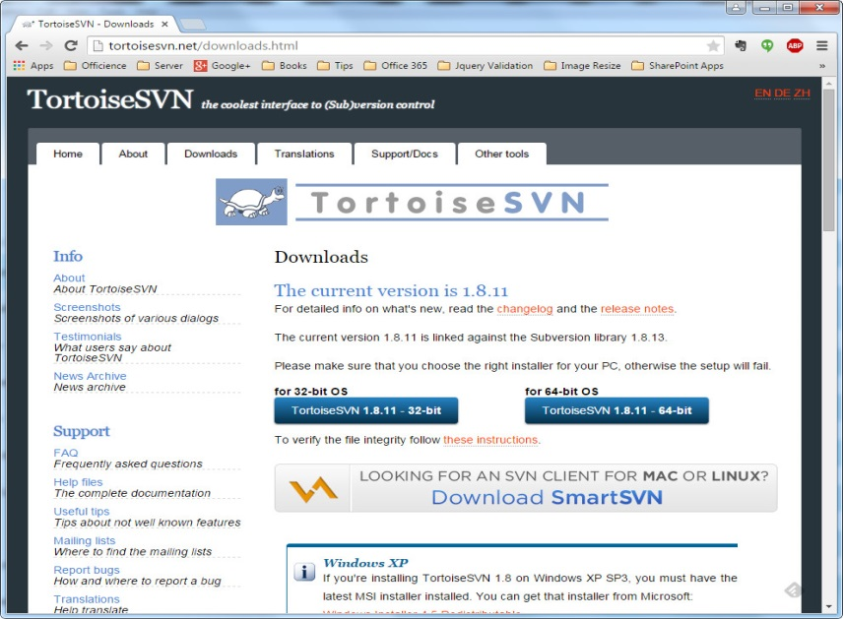**

**Step 2**: Create new repository for SVN => to store source code

**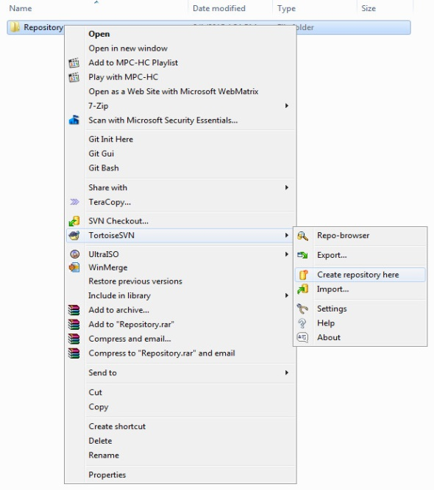**

**Step 3**: Left click on **Create folder structure**

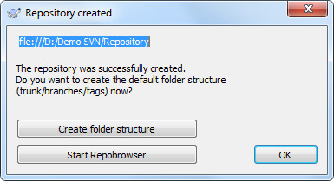

**Link to SVN**

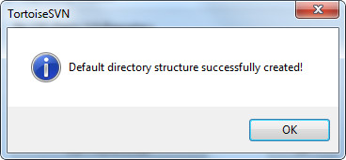

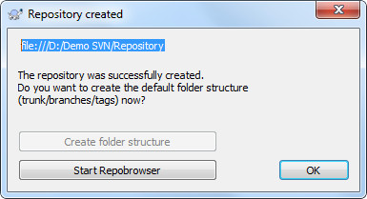

**Step 4**: Left click Start **Repobrowser** to see the folder structure

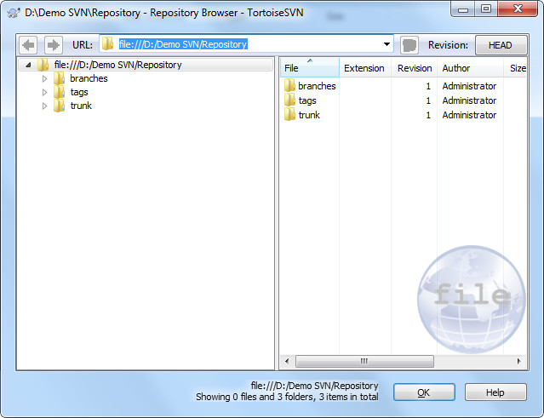

# II. SVN’s folder structure

Here is the default folder structure in SVN, we have 3 folders: **branches, tags and trunk**

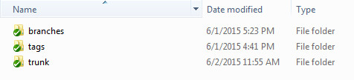

So here is the definition of each folder:

1. **Trunk**

* The development line that holds the latest source code and features
* It should have the latest bug fixes in it as well as the latest features added to the project

1. **Branches**

* Every time you release a major version, it gets a branch created
* This allows you to continue to support a production release (fix bugs) while moving forward with breaking changes in the trunk

1. **Tags**

* A release version of a product
* A snapshot of the current development
* A Tag name must be unique
* Contents of a "tag" should not be changed

**Note: You can notice that we have trunk without “s”, but branches and tags always have “s” so we will have a lot of branches and tags and only one trunk (^^).**

# III. SVN’s workflow

And here is the workflow to use SVN (normal process)

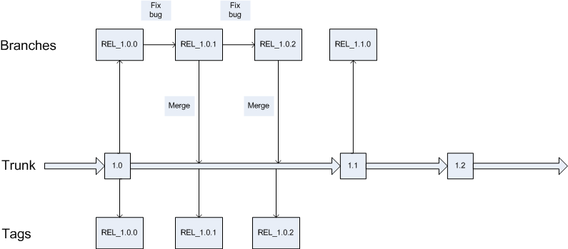

Explain:

1. Firstly, you have the main source code in trunk, before release the 1.0 version from trunk to client, you have to create new branch **REL\_1.0.0** on branches’s folder and tages’s folder also, then you can send the package in **REL\_1.0.0** to client
2. During the release period, if any bug were founded, you can fix and then create new branch name **REL\_1.0.1**, then merge with current trunk
3. Base on the trunk versions, we will have correspond branch and tag versions

**Here is the process**  
  
**Create new branch from trunk => Release to customer => Continue with trunk => Fix bug in branch => Create new branch => Merge code with trunk**

# IV. How to use SVN’s workflow

## Check out, commit source code

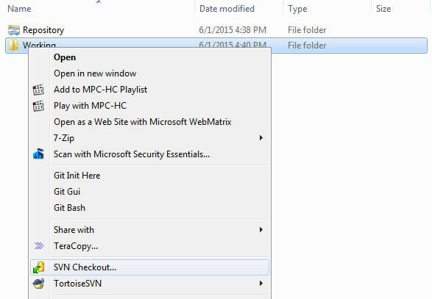

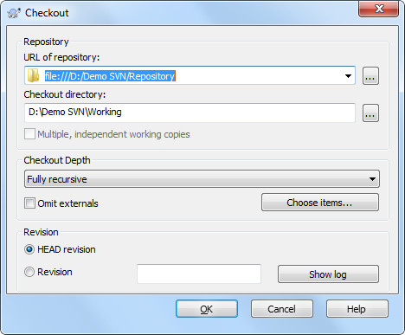

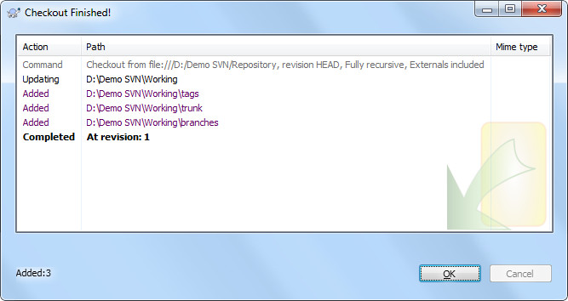

Here is the result after updating

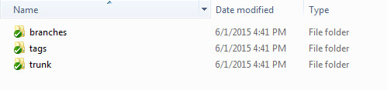

* Create new file and commit in trunk

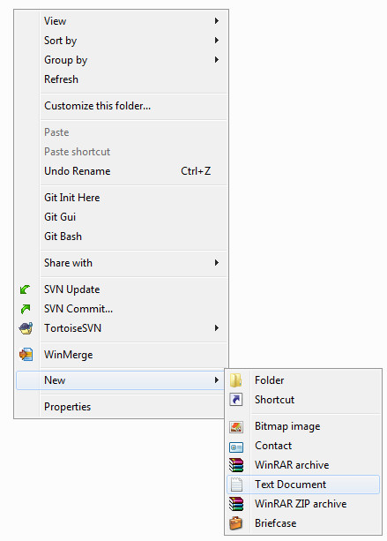

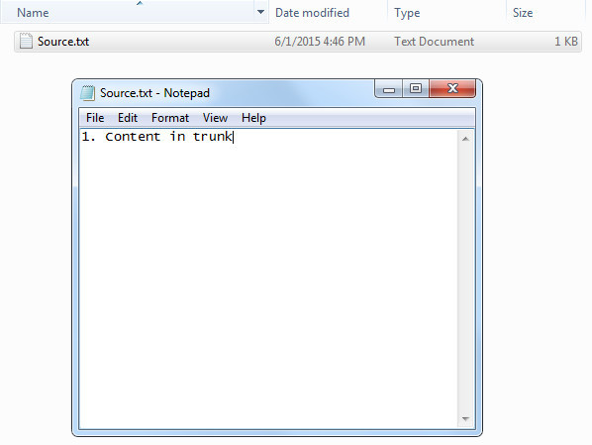

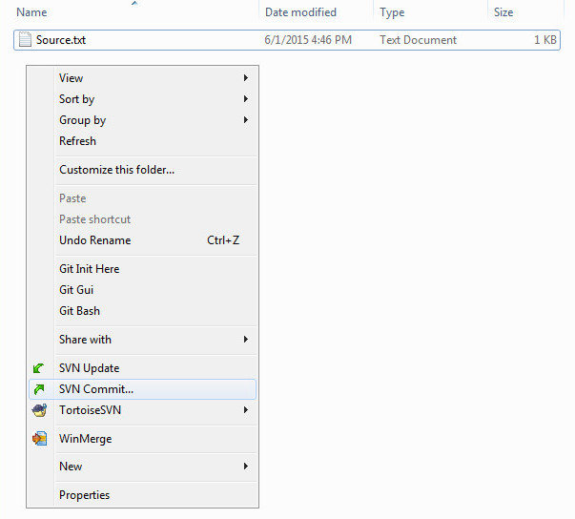

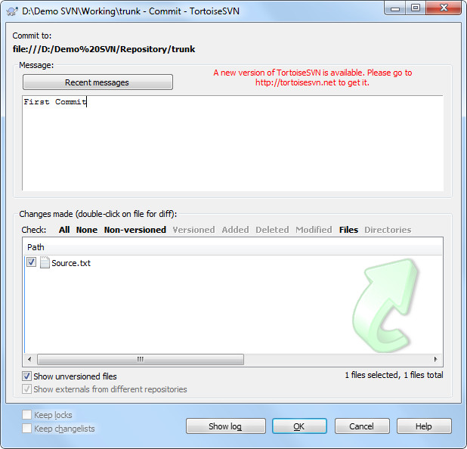

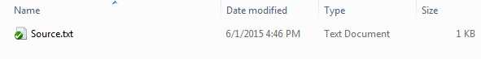

## Create new branch before release

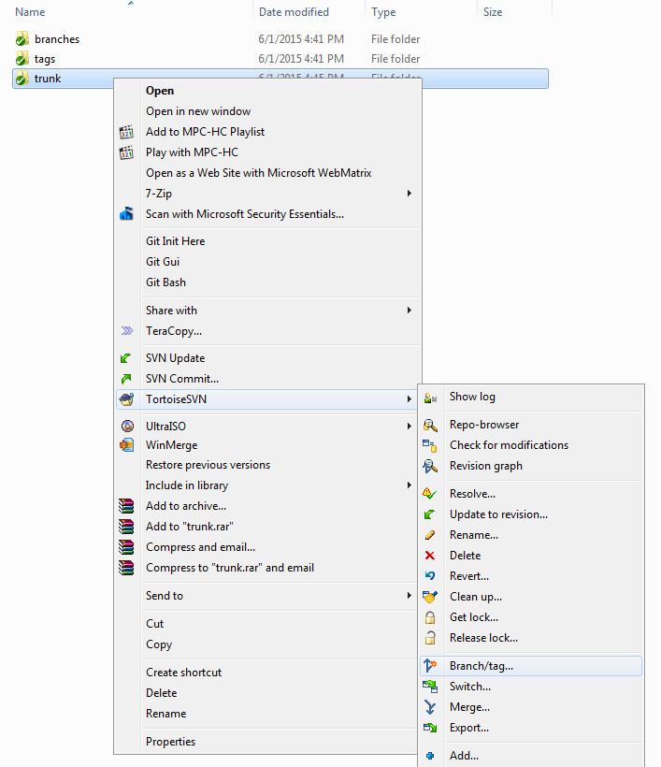

**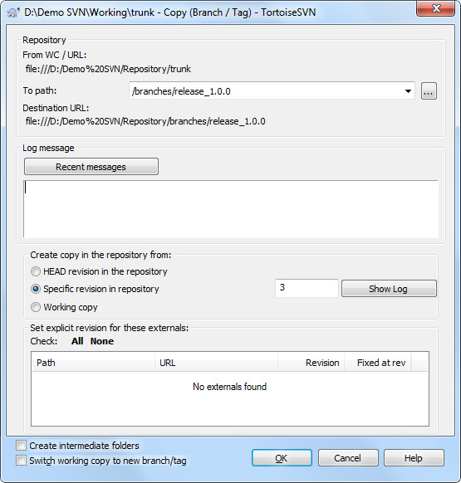**

**Note: You can choose specific revision in repository by click Show Log, by default it will be the latest revision**

**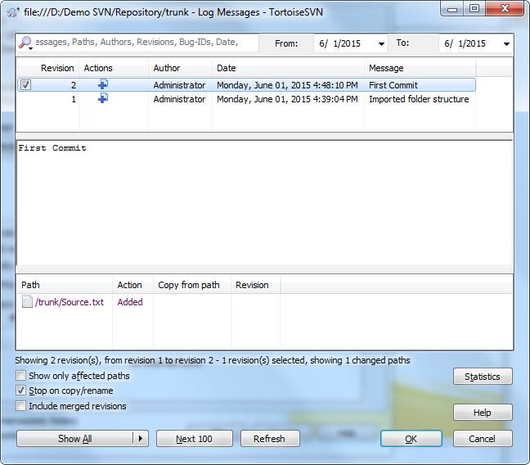**

**Choose the revision or keep the latest by default**

**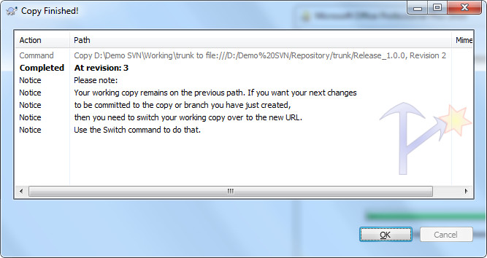**

* Then update source code in branches, you will see the new source code from trunk

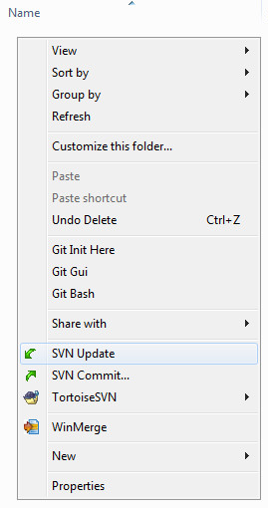

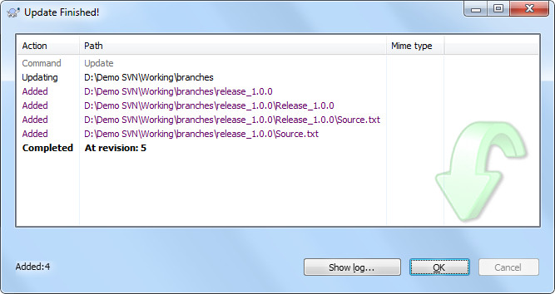

Here is the result

C:\Users\Administrator\Desktop\Svn Transfer\Step22_AterUpdateInBranch.jpg

## Create new branch after fixing bugs

After fix all bugs in branch, you have to create new branch with new version before release, you can do the same way like creating new branch from trunk but change the folder destination

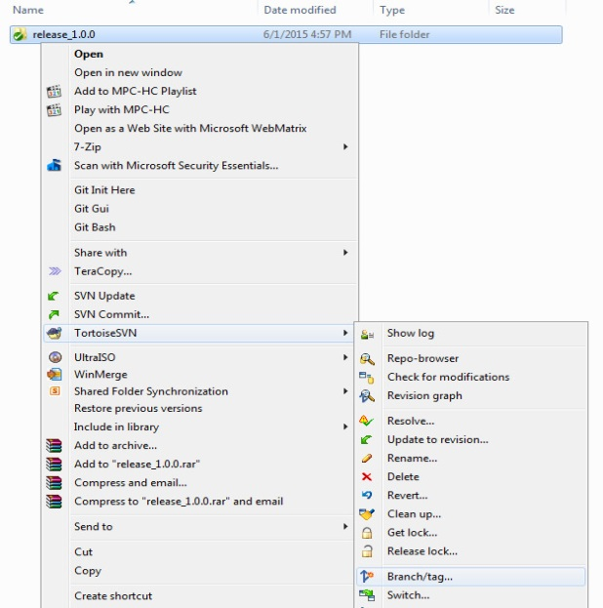

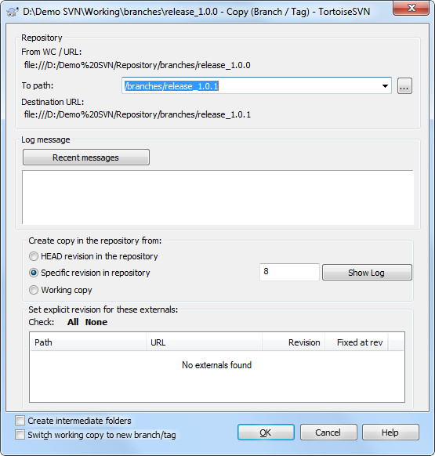

You can create the tag for each trunk and branch by the same way

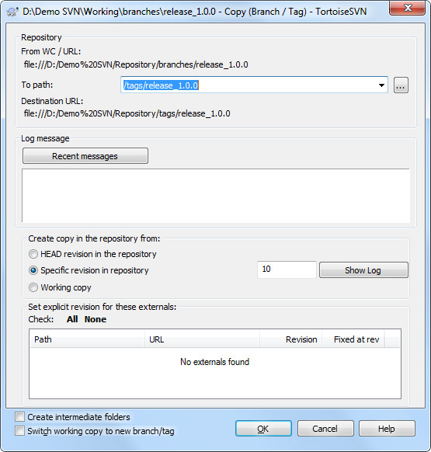

## Resolve conflict files

For example:  
We have 2 files like below:

* First file (in trunk)

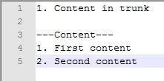

* Second file (working file)

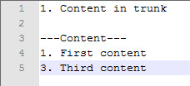

When a developer is working in the second file and he wants to commit the source, but the problem occurred

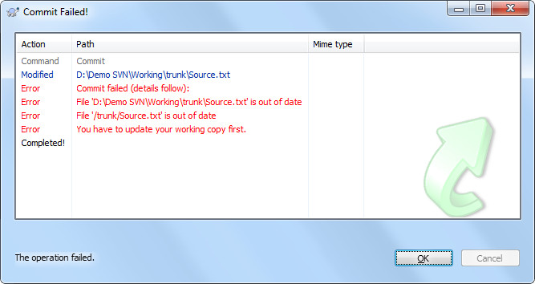

Then he goes to update the source code, but see what happen. It said the file is conflict

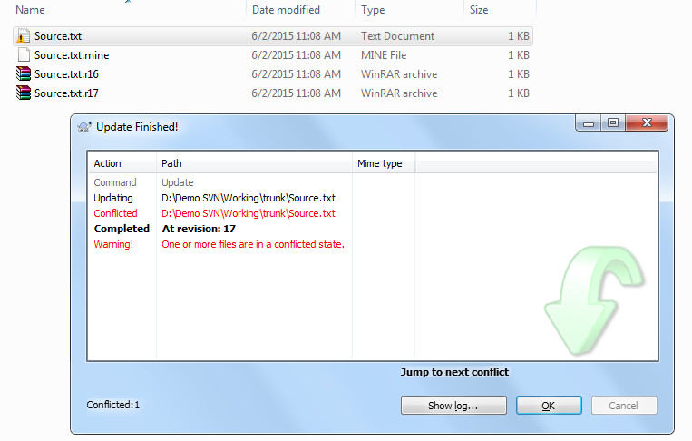

You can see the content in conflict file

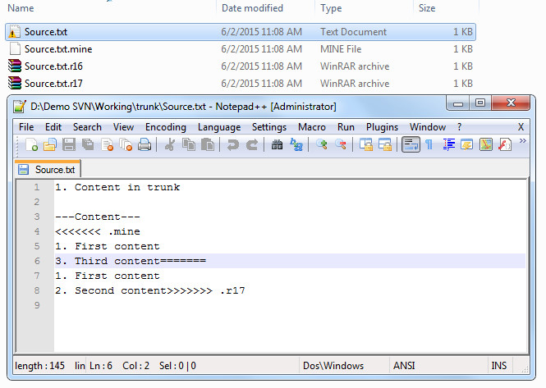

Here is the solution:

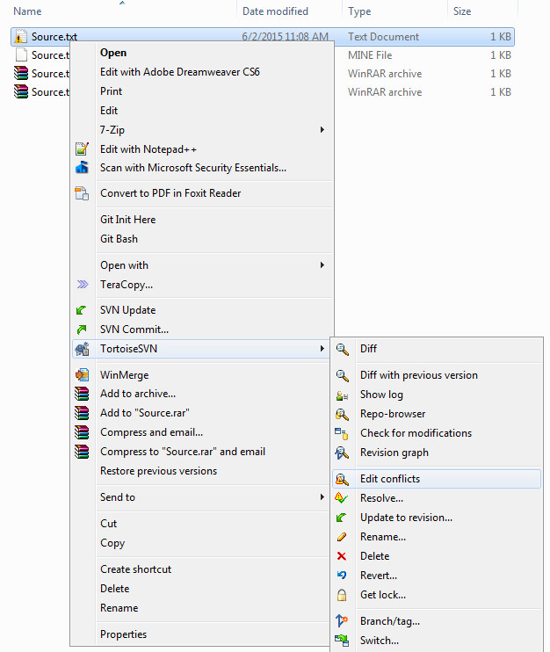

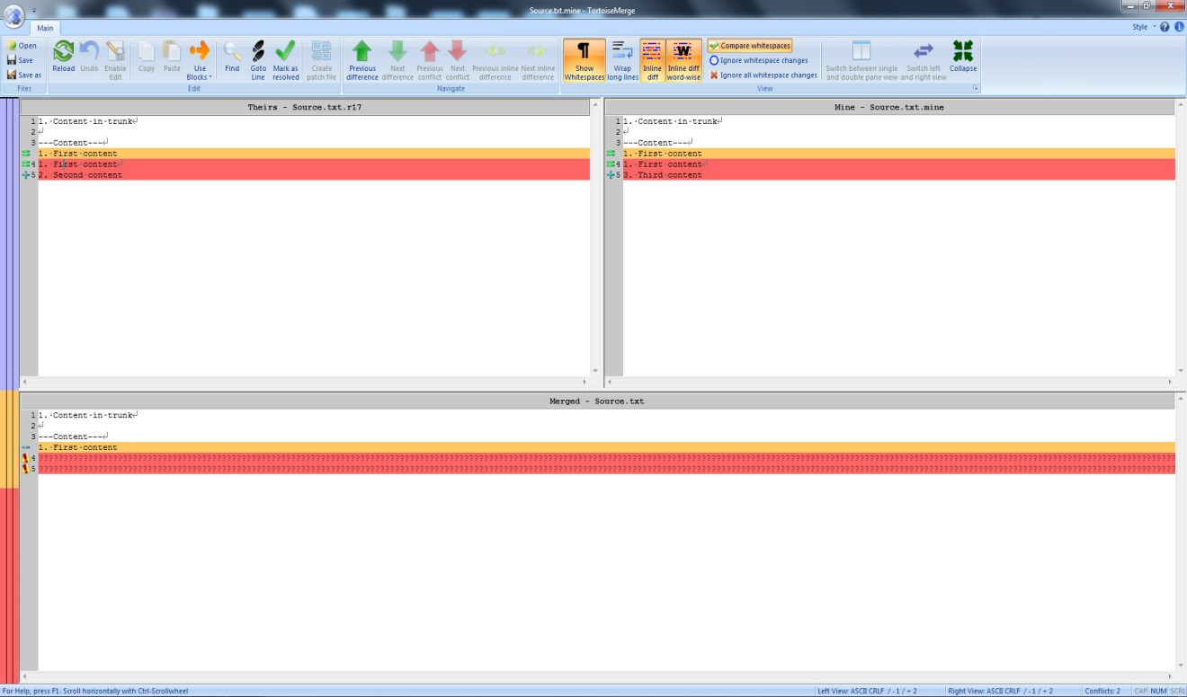

**Result panel**

**Working Panel**

**SVN Panel**

* We can copy each conflict row to result panel then save

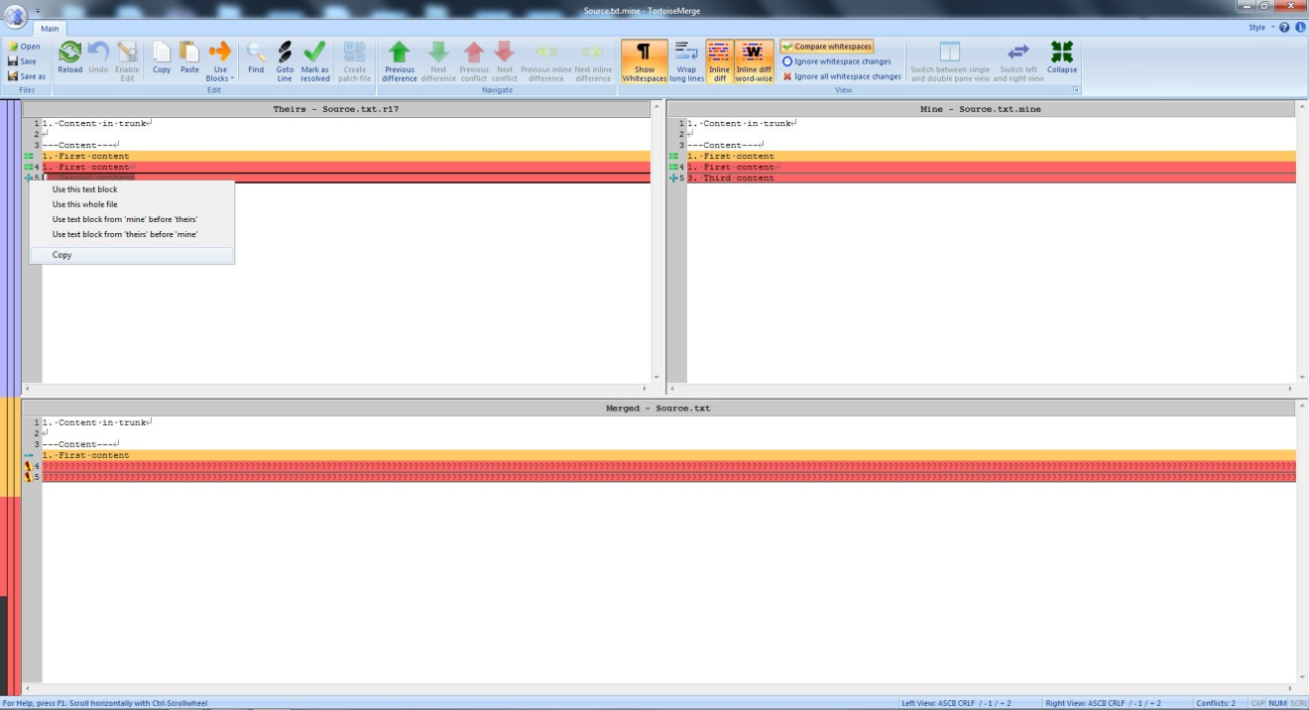

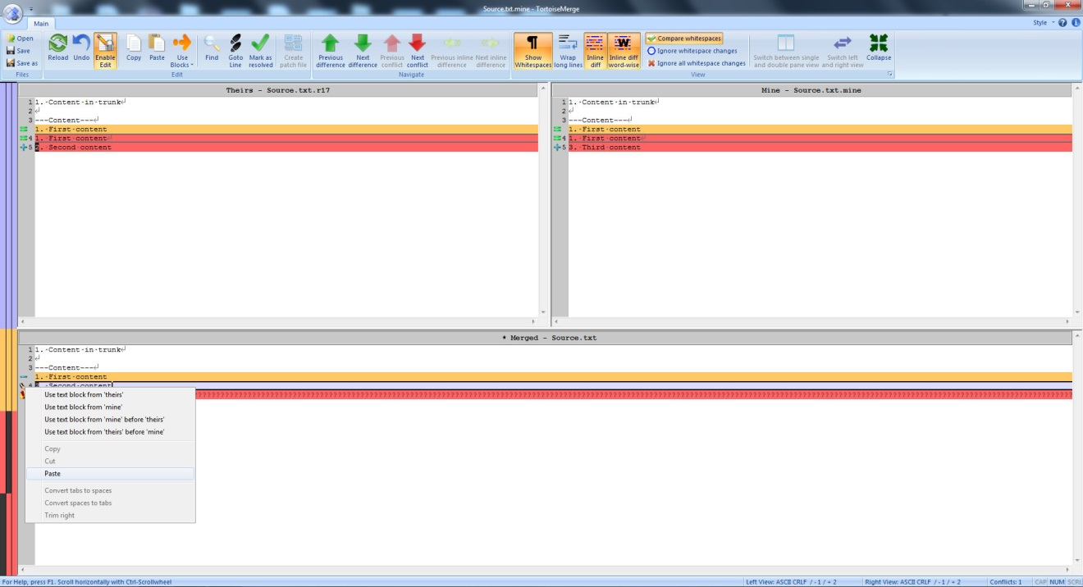

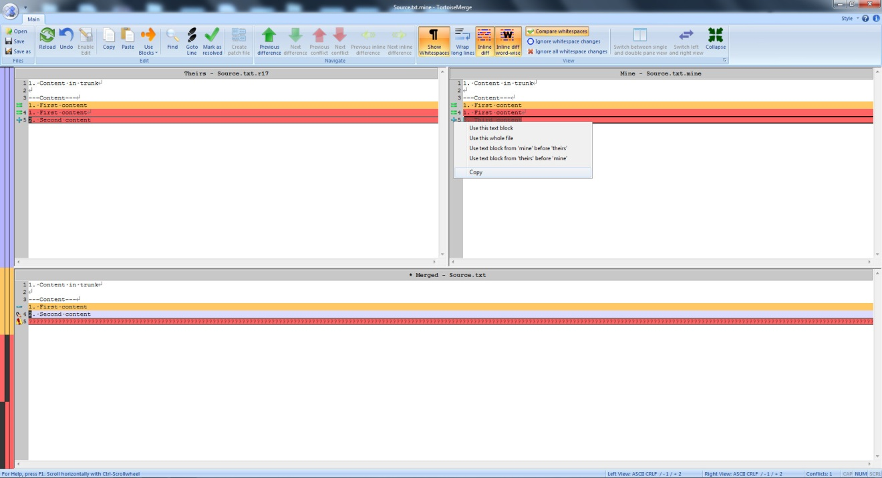

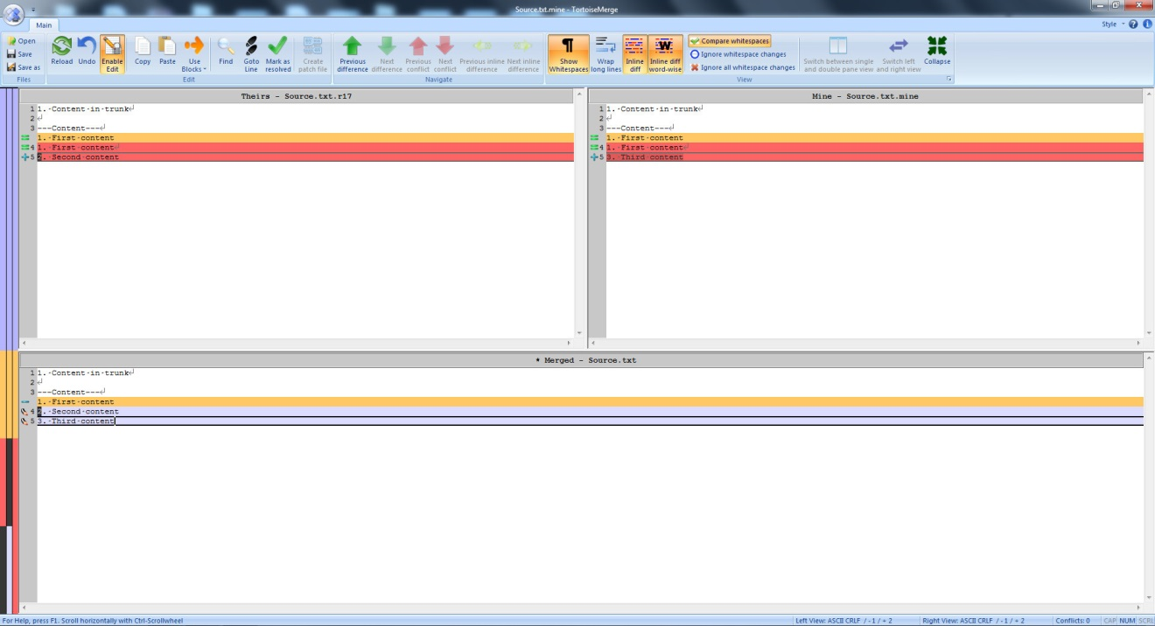

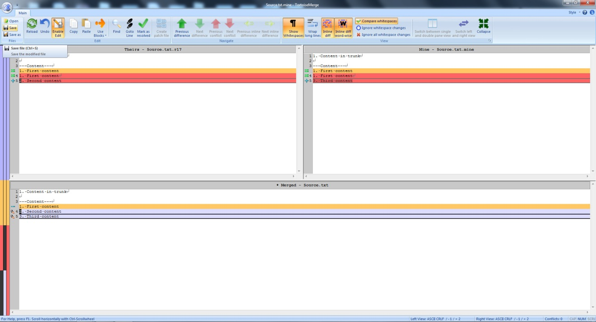

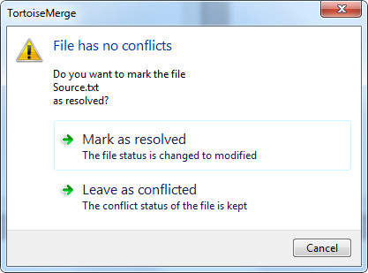

Finally, commit your source code

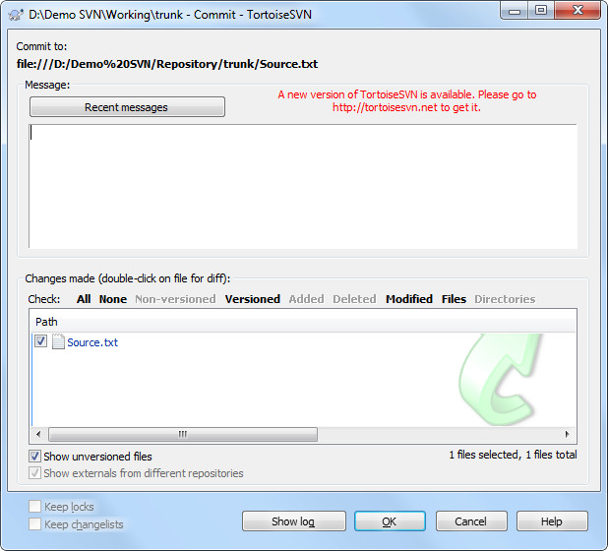

Result after resolving conflict

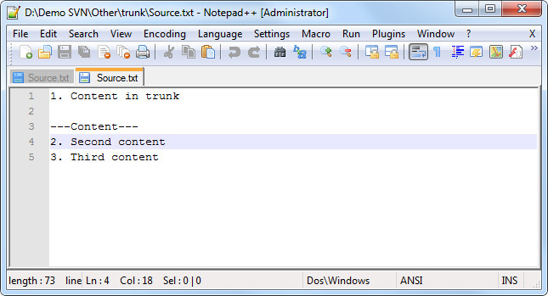

## Merging code from branches to trunk

For example, in branches you have folder **release\_1.0.1** after fixing bug

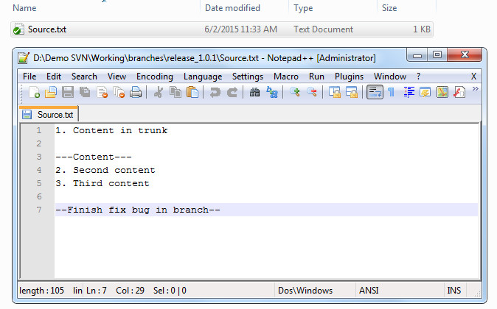

Then you want to merge this folder with current trunk

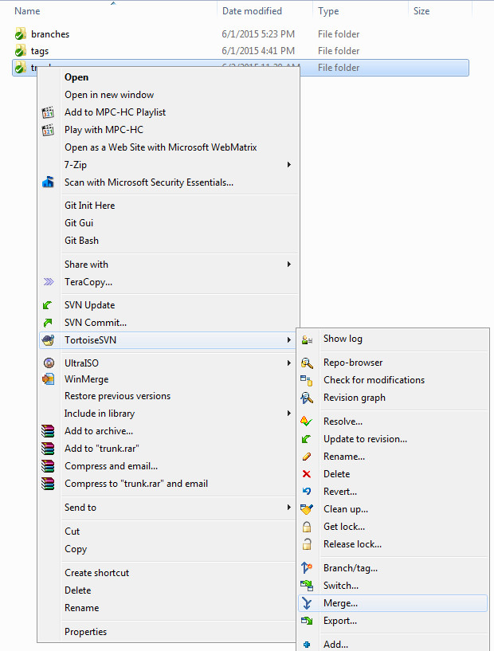

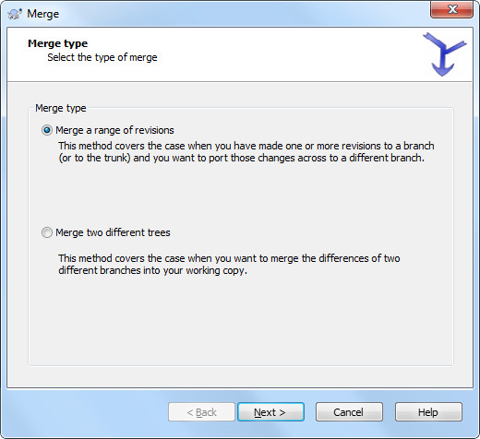

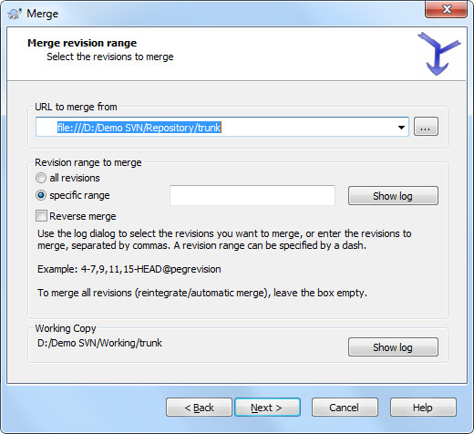

Choose the url you want to merge from by left click on **Show log**

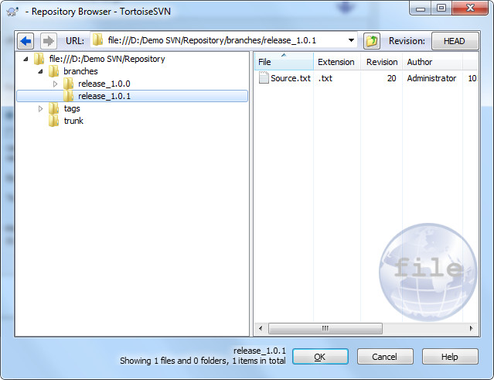

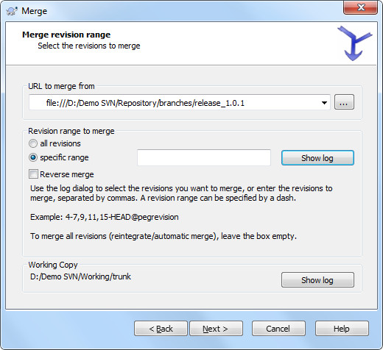

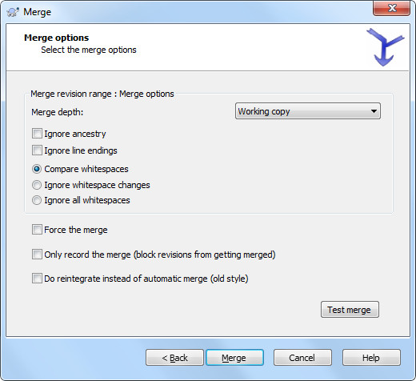

Then resolve the conflict like above

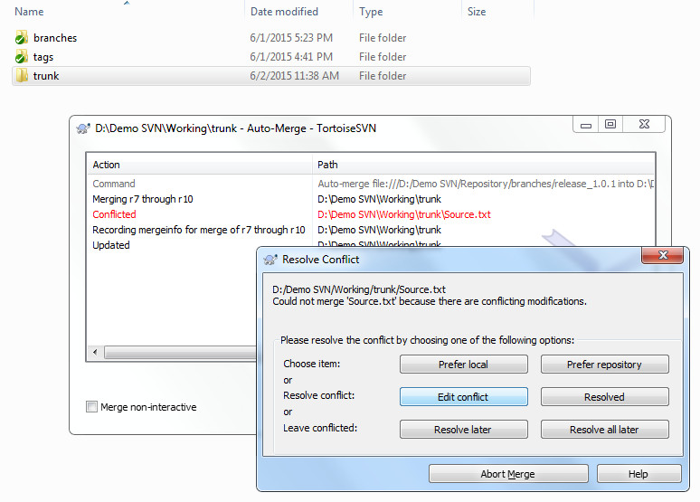

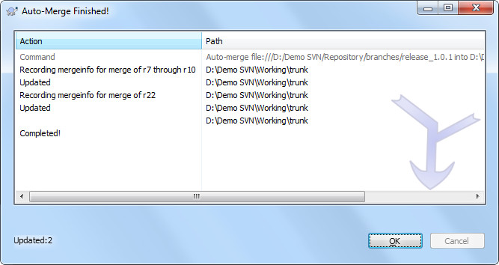

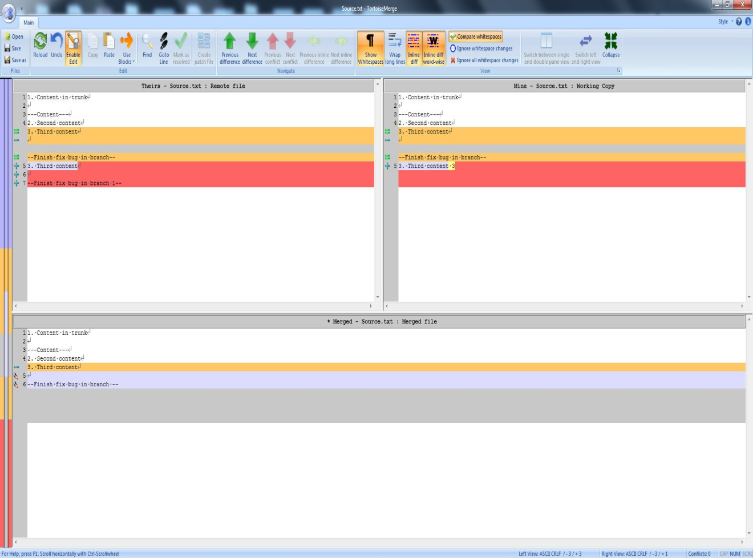

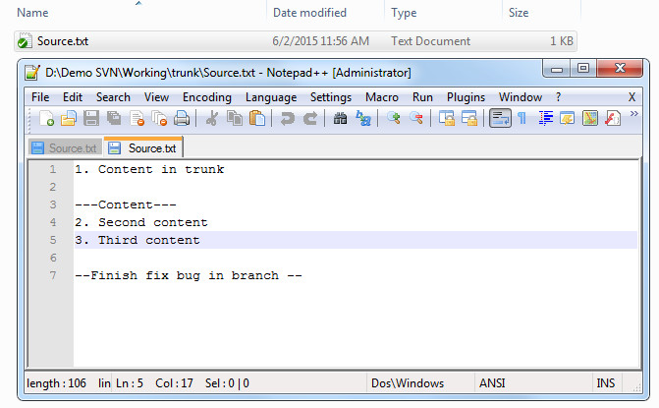

**Thanks for reading !**